**INTRODUCTION:**

IoT based Flood Monitoring System using Ultrasonic Sensor and ESP8266– This is the 2nd version of the Flood Monitoring System based on the IoT “Internet of things” based technology. Version 1 of the Flood monitoring system was based on the Arduino and GSM based Flood alert system.

Those projects send the Flood alert values after every 10 or 20 seconds. These are long delays, due to which the water levels cannot be monitored in real-time. We need a quick system that can send the values at least every 1 second.

The IoT-based Flood Monitoring System that we are going to build is capable of sending the water level data at 1 second interval, due to which the water level can be monitored in real-time using the cell phone application designed in Blynk. My designed IoT based Flood Monitoring system is based on the Nodemcu ESP8266, Ultrasonic Sensor “HC-SR04”, and Blynk Application. All the processing is done by the Nodemcu ESP8266.

In this project the Ultrasonic Sensor is used for measuring the distance. When the distance between the Ultrasonic Sensor and the water level is less than or equal to 10 an alert message is sent to the Blynk application. On the Blynk application I have added the widgets which display the distance values

My previously designed Flood monitoring system was based on the GSM and Arduino. This GSM based flood monitoring system also works perfectly. It can generate alert messages. The only drawback is we cannot monitor the water level in real-time, and moreover messages takes time to send. This is the reason I decided to make another Flood Monitoring system using IoT.

**BLOCK DIAGRAM FOR FLOOD MONITORING:**

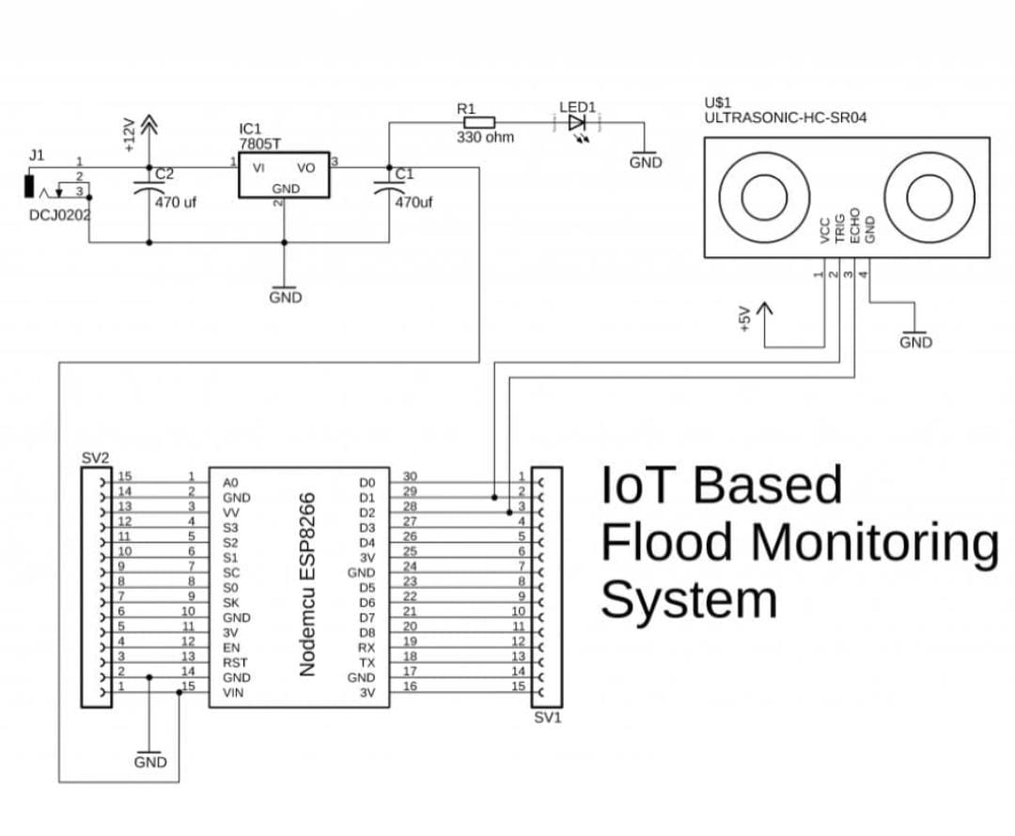

The blockt diagram of the IoT based Flood Monitoring System is very simple. The Nodemcu ESP8266 WiFi module is powered up using the 5V regulated power supply based on the LM7805 Voltage regulator. As the LM7805 Voltage Regulator accepts a wide range of input voltages (7 to 25 Volts), this project can be powered up using a 12V battery, a solar Panel, etc. Make sure the Input voltage does not exceed the maximum input voltage of the LM7805 Voltage Regulator.

Two resistor R2 “4.7K” and R3 “10K” are connected in series which makes the voltage divider circuit. This simply works as the voltage level converter; it converts 5 volts from the Ultrasonic Sensor into 3.3Volts.

**Components Required**

* **ESP8266 NodeMCU**
* **Ultrasonic Sensor**
* **Power supply**
* **LEDs (Red & Green)**
* **Breadboard**
* **Jumpers**
* **Resisters**

**CIRCUIT DIAGRAM:**

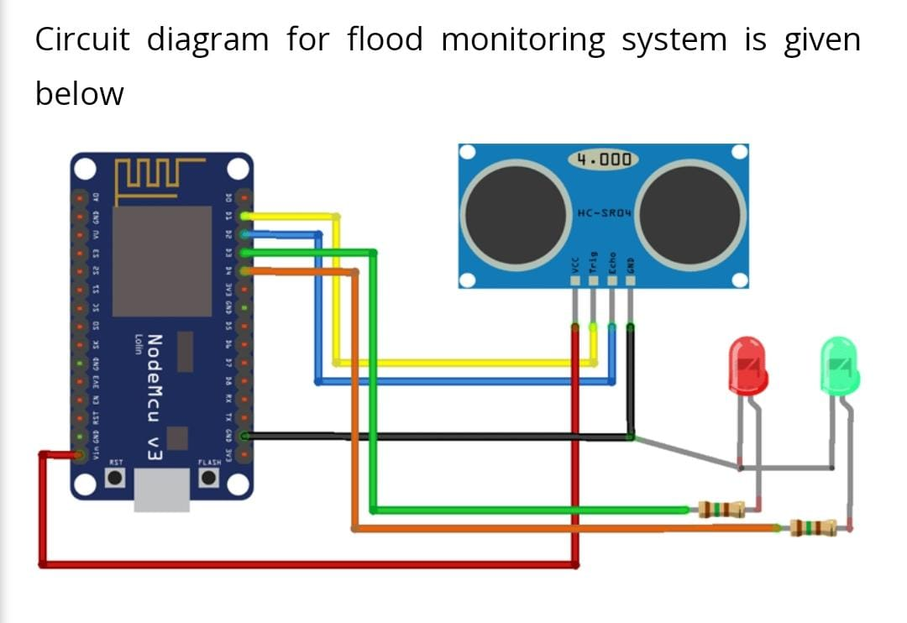

The circuit diagram of the IOT based flood monitoring sytem is very simple .Here we are using an ultrasonic sensor to sense the river levels and a NodeMCU ESP8266 to process these data. The data will be uploaded to ThingSpeak IoT cloud, using which the river levels can be graphically monitored from anywhere in the world.

**WORKING OF FLOOD MONITORING SYSTEM**

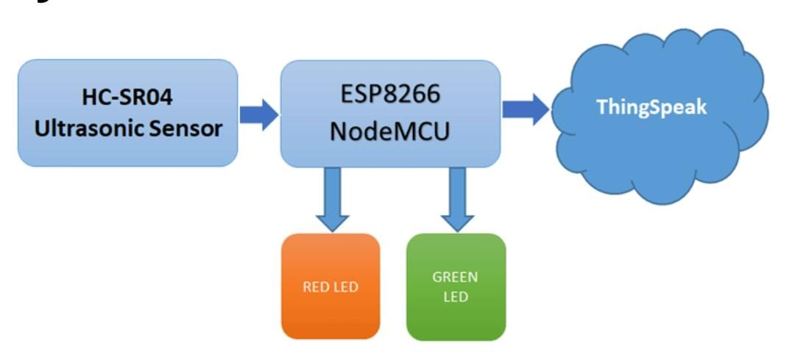

We previously used ESP8266 NodeMCU to build many IoT projects. The above block diagram shows the working of this IoT based flood monitoring system. Here, the ultrasonic sensor is used to sense the water level of the river. The data output from the ultrasonic sensor is fed to the NodeMCU, where it is processed and sent to ThingSpeak for Graphical monitoring and Critical alert. Here, a red LED is used to alert during the critical flood conditions, and the Green LED is used to indicate the normal condition.

**FEATURES:**

* Working Voltage: 5V
* Working Current: 15mA
* Working Frequency: 40HZ
* Measuring Distance: 2cm-4m
* Measuring Angle: 15 Deg.
* Triggering input pulse: 10uS

**CONCLUSION:**

The proposed model is an efficient model which helps in preventing flood due to sudden flush out of excess water at barrage at a time. In this model the water at barrage is flushed from the barrage in a controlled manner so that flood in the plain area will occur. The advantages of this model are that we are using minimum number of parameter. We are also including the less battery energy consumption method. This model is a cost effective model. Hence this can be deployed by developing and poor country to fight back with flood.